**Problem 6 : Form Validation using JS**

**AIM:**

Create a HTML form and perform form validation using JS. Report errors using alert messages.

**PROGRAM CODE:**

|  |  |  |
| --- | --- | --- |
| Index.html | | <html>  <body>  <style>  body{  background-color:lavender;  }  </style>  <div>  <form name="myForm" action="thankyou.html" onsubmit="return check()" method="post">  <table>  <tbody>  <tr><td><label for="name">Name:</label></td><td><input id="name" type="text"></td></tr>  <tr><td><label for="email">Email Address:</label></td><td><input id="email" type = "text"></td></tr>  <tr><td><label for="desc">Comment:</label></td><td><textarea id="comment"></textarea></td></tr>  <tr><td></td><td><input type="submit" value="Submit"></td></tr>  </tbody>  </form>  </div>  <script>  function check() {  var x = document.forms["myForm"]["name"].value;  var y= document.forms["myForm"]["email"].value;  var z= document.forms["myForm"]["comment"].value;  if (x == "") {  alert("Name must be filled out");  return false;  }  else if (y == "") {  alert("Email must be filled out");  return false;  }  else if (z == "") {  alert("Comment must be filled out");  return false;  }  }  </script>  </body>  </html> |
|  |

**RESULT**

These are the output display of pages that are specified in the aim of the program

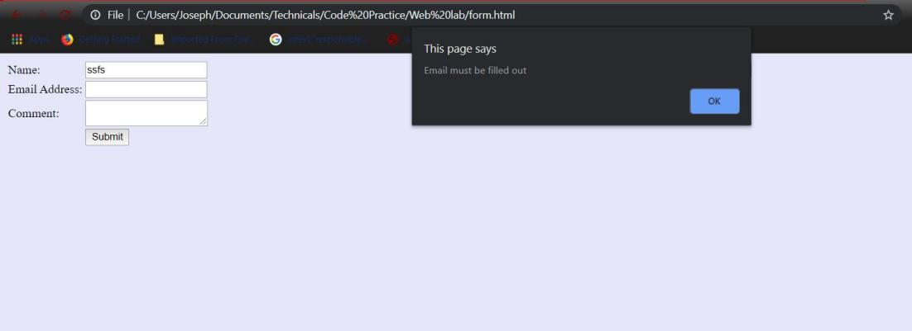

Figure 1: Webpage shows the form validation